Name Date

Test A

Chapter

1

Find the value of the expression. Use estimation to check your   
answer.

Answers

1.

2.

3.

4.

5.

6.

7.

8.

9.

10.

11.

12.

13.

14.

15.

16.

17.

18.

19.

20.

21.

22.

23.

1.  2. 

3.  4. 

Determine the operation you would use to solve the problem. Do not answer the question.

5. A shopper gives a cashier $60 to pay for a $49 item. How much does the cashier owe the shopper?

6. A movie theater has 18 rows with 15 seats each. How many seats does the theater have?

7. A farmer has 450 eggs. Egg cartons hold 12 eggs. How many cartons does the farmer need?

**Find the value of the power.**

8.  9. 

Determine whether the number is a perfect square.

10. 100 11. 42

Evaluate the expression.

12.  13. 

14.  15. 

Write the prime factorization of the number.

16. 38 17. 54

Find the GCF of the numbers.

18. 16, 28 19. 18, 60

Find the LCM of the numbers.

20. 6, 8 21. 24, 32

Add or subtract. Write the answer in simplest form.

22.  23. 

Name Date

Test A **(continued)**

Chapter

1

Answers

24.

25.

26.

27.

28.

29.

24. An electrician charges $322 for 7 hours of work. How much does   
the electrician charge per hour?

25. What is the area of the square helicopter landing pad?

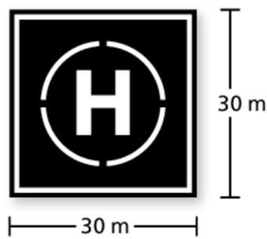

26. The point system below is used to rank teams in a hockey league.   
A team’s record is 29 wins, 5 ties, and 22 losses. How many points   
does the team have?

|  |  |
| --- | --- |
| **Result** | **Points** |
| Win | 2 |
| Tie | 1 |
| Loss | 0 |

27. A class of 54 students is divided into equal groups for orientation.   
Each group should have at least 7 students but no more than   
10 students. What is the group size?

28. You are creating identical candy bags using 18 chocolate bars and   
30 peanut butter cups. What is the greatest number of bags you can   
fill using all the candy?

29. You have violin lessons every fourth day and singing lessons every   
fifth day. Today you have both lessons. In how many days will you have both lessons on the same day again?