Poster Project: Independent vs. Dependent Variables

WHO: You (and everybody else).

WHAT: Make a poster (8.5" by 11" or bigger) that uses pictures to show the difference between a dependent and independent variable.

HOW: Find or think up two example of a dependent and independent variable (use the list below to start, you have to find one other than the example I list). Your posters must have: 2 pictures, one to illustrate each variable (drawn, cut out from newspaper or magazines, or printed out from the Internet), a title, labels for "dependent variable" and "independent variable", and a caption that says:

______________________ depends on _______________________.
Your dependent variable your independent variable

WHY: To show mastery of dependent and independent variables

WHEN: Due Tuesday, 04/04

EXAMPLES: (example poster on back)

DEPENDENT | INDEPENDENT
Cell phone bill | Minutes used
How far you can drive | The amount of gas you have
Your Six Weeks grade | The number of assignments you turned in
How much money you earn | The hours you work
Cost of a speeding ticket | How many miles you went over the speed limit
Time it takes to drive somewhere | How fast you drive
Result of a football game | Who scores more points
How much air conditioning you use | Temperature
Total calories and fat | Number of What a burgers
Opportunities for high-paying jobs | How much education you have

Grading Rubric:
- Following directions: Did they include all of the elements required (pictures/drawings, explanation, labels)?
- Clarity: Does their example make sense and is easy for others students to understand?
- Effort: Did the student put in time and effort into making the poster colorful, attention grabbing, and easy to read and see from afar?
Independent | Dependent
Cause | Effect
Before | After
Input | Output
What you do | What happens

Poster Example: you can show your work on a regular print paper, not have to be a big poster.

Independent Variable VS Dependent Variable
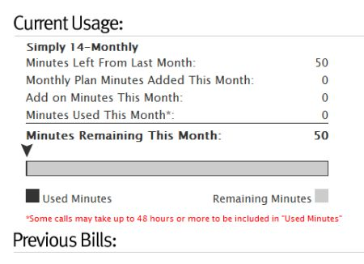
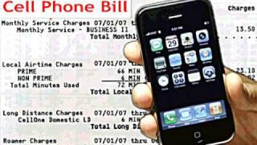

Dependent Variable: Cell phone Bill Independent Variable: How many minutes used

Your cell phone bill depends on how many minutes you used per month. The more minutes you used, the more money you needed to pay for your cell phone bill.

